

**Mustafa Tahir BSE173087**

**Awais Ahmad Khan BSE173080**

**Faizan Ashraf BSE173070**

**Subject: Software Testing**

**Section: 02**

**Assignment: 04 & 05**

Table of Contents

**MCDC .** 2

**Decision Statement 1.** 2

**1.1 Implementation** 2

**Decision Statement 2** 3

**1.2 Implementation** 3

**Flow Chart:** 4

**Path Predictions:** 4

**1st Path Prediction:** 4

**Path:** 4

**2nd Path Prediction:** 4

Path: 4

**3rd Path Prediction:** 5

**Path:** 5

**4th PathPrediction**:………………………………………………………….. ………………………….5

**Path**……………………………………………………………………………………………………5

**5th Path Prediction:………………………………………………………………………………………...5**

**Path:…**………………………………………………………………………………………………..5

**Test Oracle:** 5

**Expected Outputs**: 5

**MCDC:**

1. **Statements**

public int agebasedhumanclassification(int age){

if ( (age<0) {

System.out.print("age must me positive number");

return 0;

}

else if ( (age >0&&age<=12) {

System.out.print("Child");

return 0;

}

else if ((age > 12 && age<=18){

System.out.print("Adolescence");

return 0;

}

else if ((age >= 19 && age<60){

System.out.print("Adult");

return 0;

}

else if ((age > 60){

System.out.print("Senior Adult");

return 0;

}

}

1. **else if ( (age >0&&age<=12)**

* 1. **Decision Statement**

|  |  |  |  |
| --- | --- | --- | --- |
|  | Input | Output |  |
| **Condation1** | **Condation2** |  |  |
| T | T |  | T |
| T | F |  | F |
| F | T |  | F |
| F | F |  | F |

* 1. **implement test cases**

|  |  |  |
| --- | --- | --- |
|  | Input | output |
| **Age** | | else if (age>0&&age<=12) |
| 0 | | Child |
| -1 | | age must me positive number |
| 5 | | Child |
| 12 | | Child |
| 13 | | Adolescence |

**2.** **else if ((age > 12 && age<=18)**

**2.1 Decision Statement**

|  |  |  |
| --- | --- | --- |
|  | Input | Output |
| **Condation1** | **Condation2** |  |
| T | T | T |
| T | F | F |
| F | T | F |
| F | F | F |

**2.2 . implement test cases**

|  |  |
| --- | --- |
| Input | Output |
| **Age** | **else if ((age > 12 && age<=18)** |
| 12 | child |
| 13 | Adolescence |
| 16 | Adolescence |
| 18 | Adolescence |
| 19 | Adult |

**Flow chart Graph :**

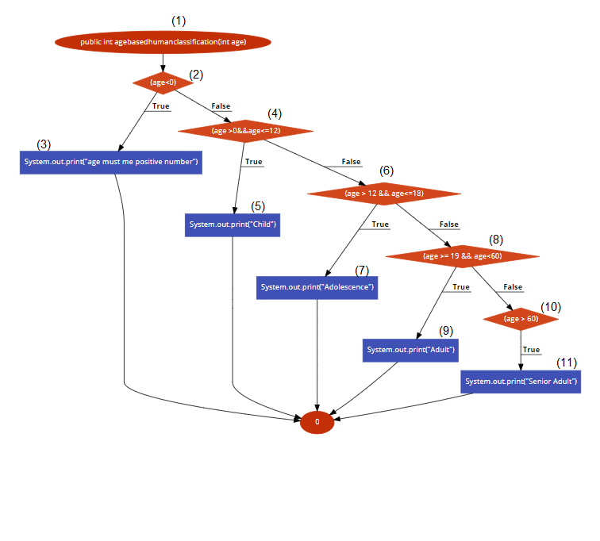

**Path Prediction:**

**Path 1**

1→2→3

**Expression**

if ( (age<0)

**Path 2**

1→2→4→5

**Expression**

**if ( (age >0&&age<=12)**

**Path 3**

1→2→4→6→7

**Expression**

**Path 4**

1→2→4→6→**8**→**9** 

**Expression**

else if ((age > 12 && age<=18)

**Path 5**

1→2→4→6→**8**→**10**→**11** 

**Expression**

else if ((age > 60)

## Test Oracle

|  |  |  |  |  |
| --- | --- | --- | --- | --- |
| **Test Path** | **Input** | | **Original** | **Expected** |
|  | **Age** |  |  |  |
| 1→2→**3** | -1 | True | age must me positive number | age must me positive number |
| 1→2→4→5 | 5 | True | Child | Child |
| 1→2→4→6→7 | 16 | True | Adolescence | Adolescence |
| 1→2→4→6→**8**→**9** | 25 | True | Adult | Adult |
| 1→2→4→6→**8**→**10**→**11**  | 70 | True | Senior Adult | Senior Adult |